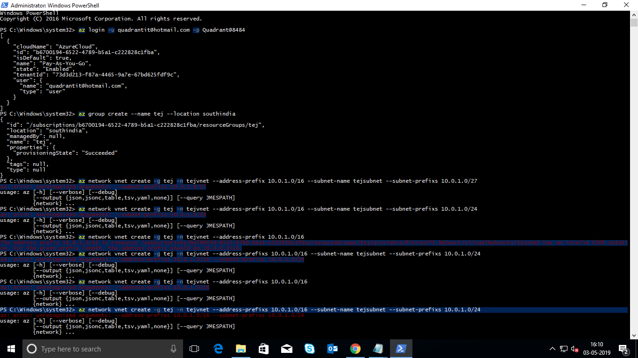

Created a Resource group

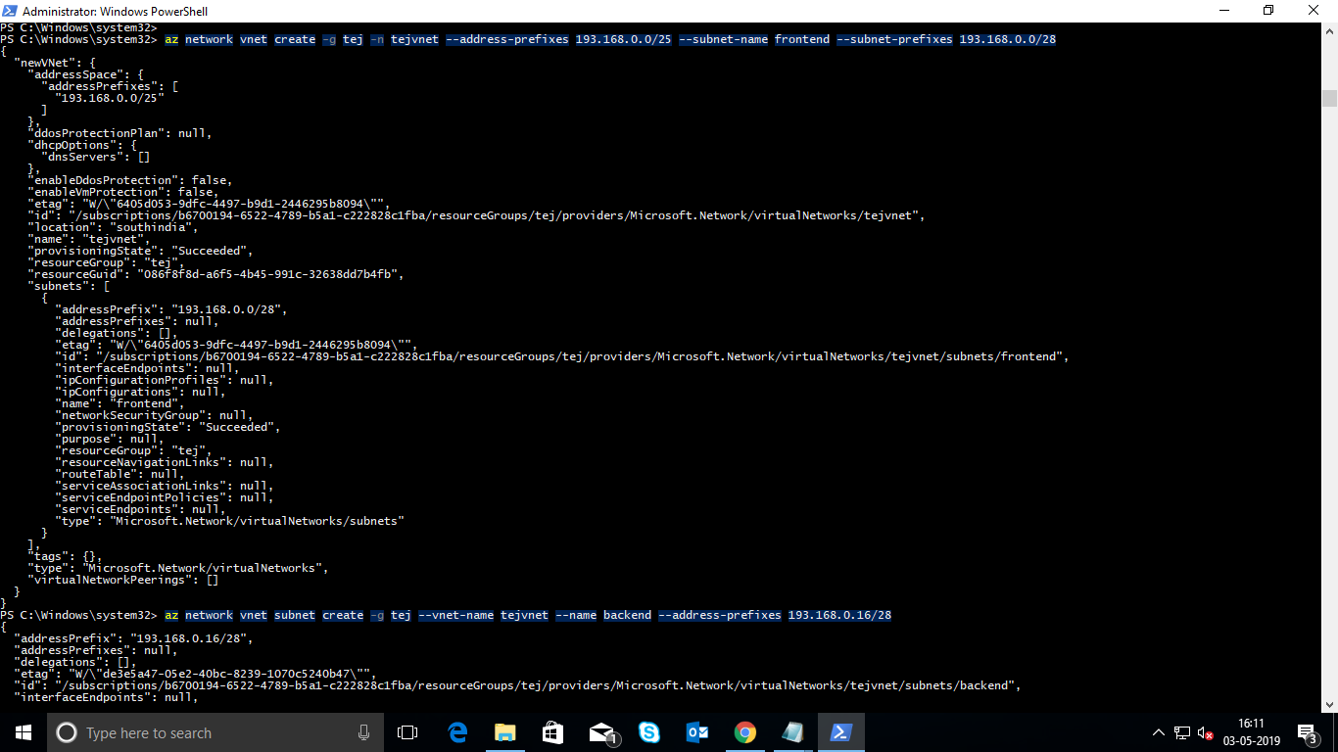

Created a Vnet and Subnets

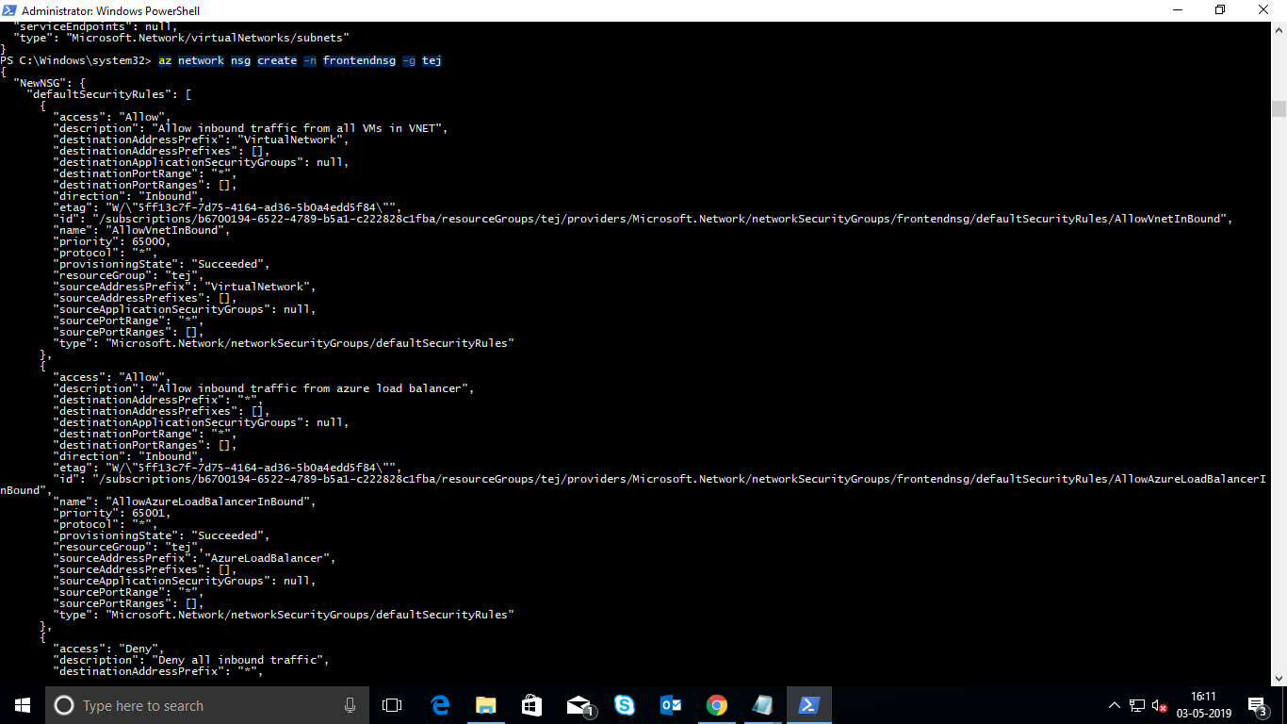

Created a frontend for NSG group

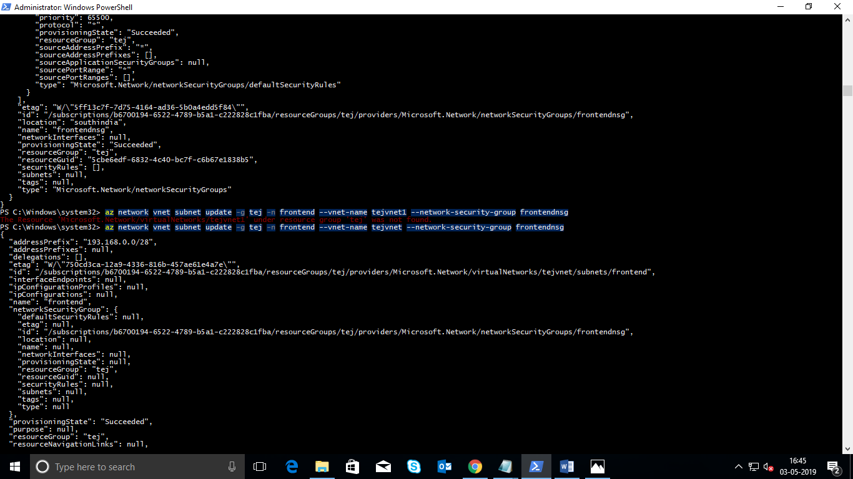Update on Frontend NSG group

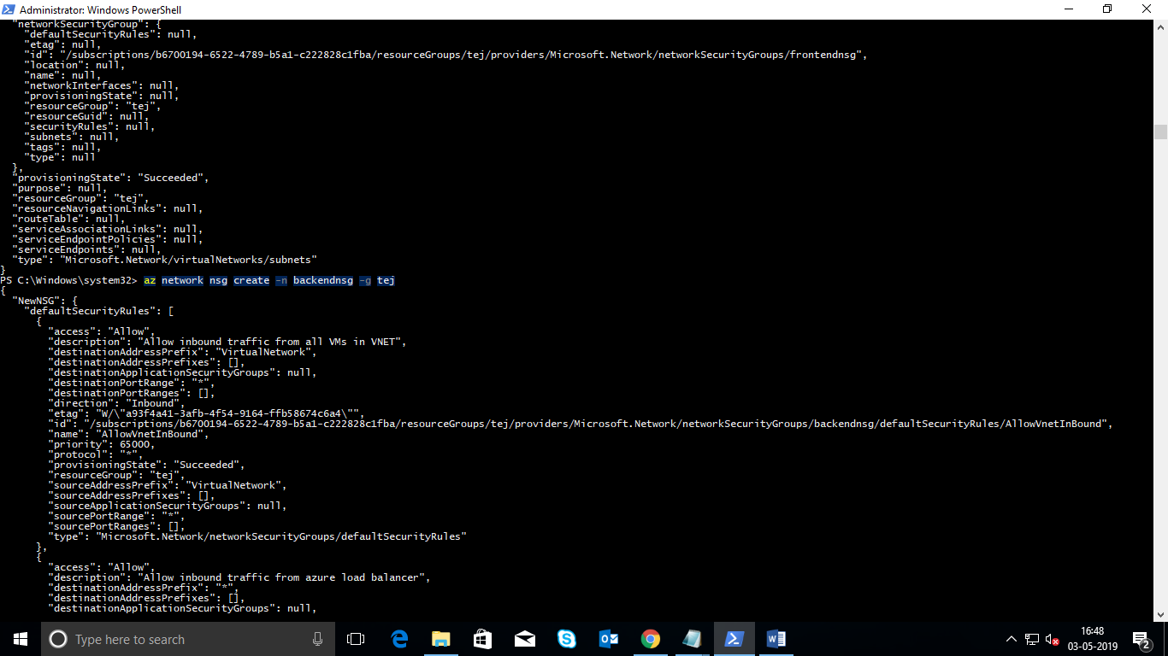

Created a Backend for NSG group

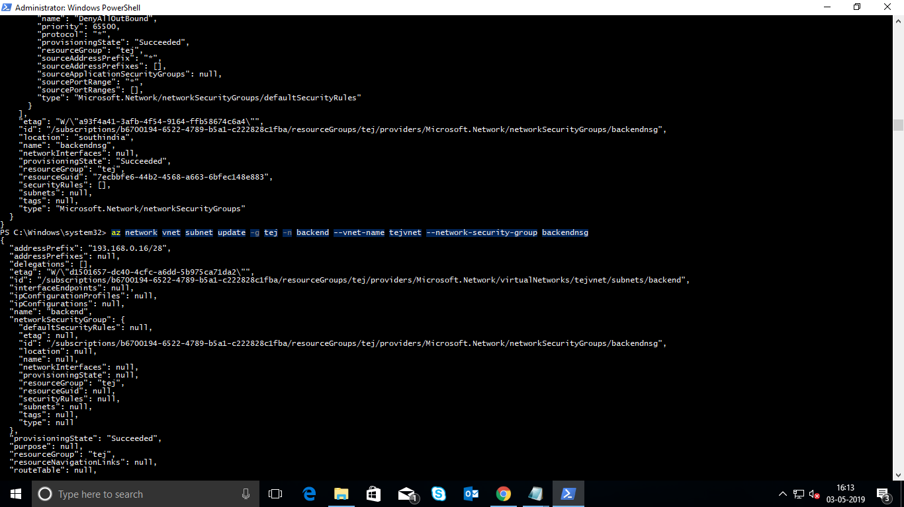

Update on Backend NSG group

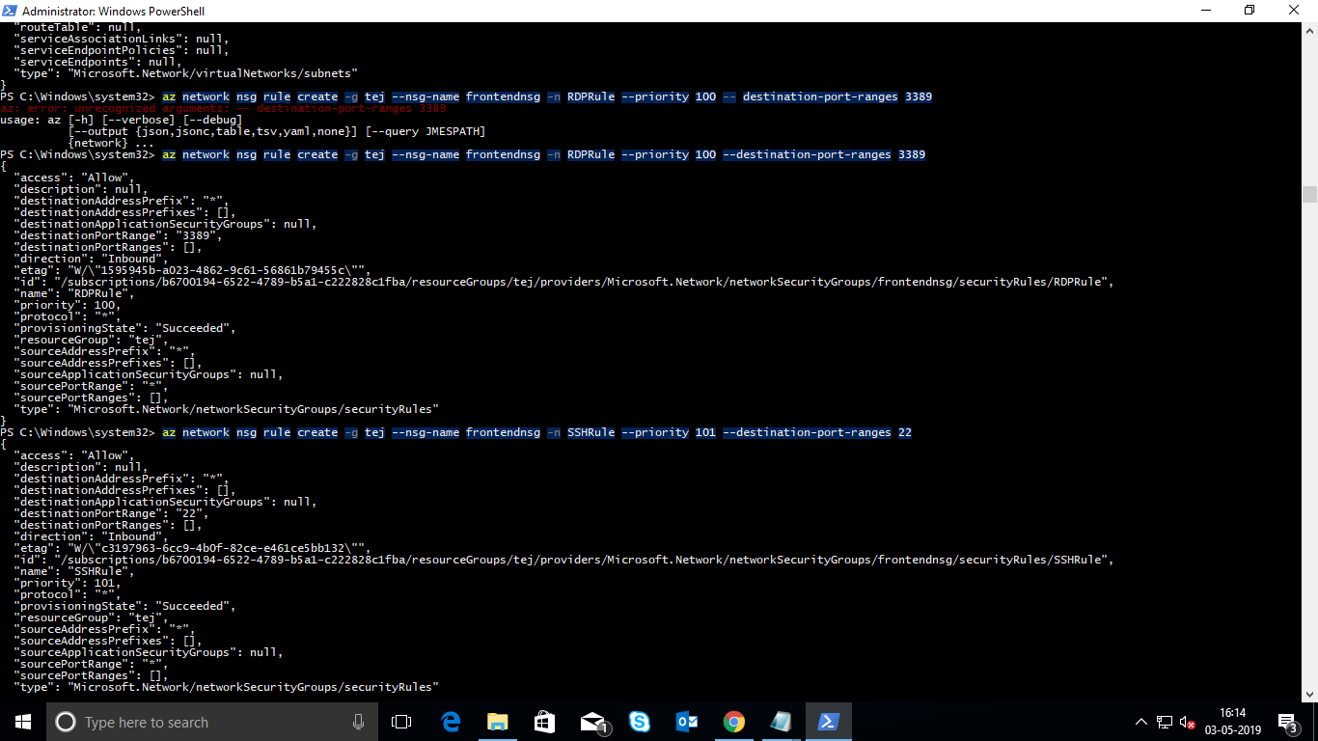

Created a InBound Properties RDP rule and SSH rule in the frontendnsg Group

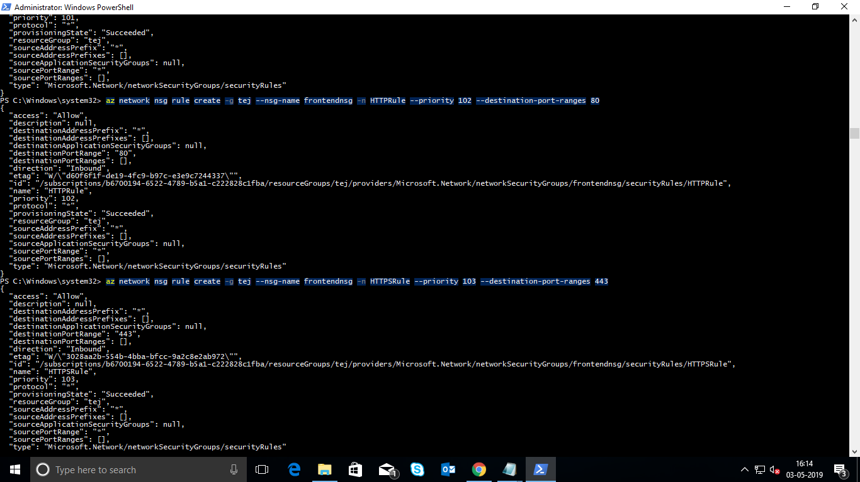

Created a InBound Properties HTTP rule and HTTPS rule in the frontendnsg Group

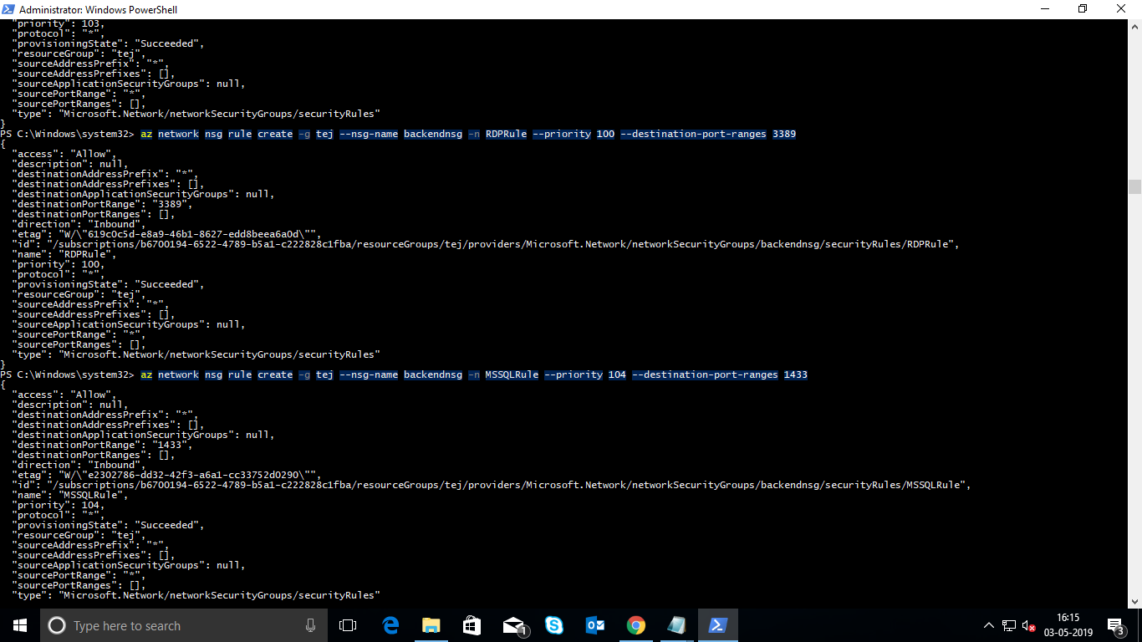

Created a OutBound Properties RDP rule and MSSQL rule in the Backendnsg Group

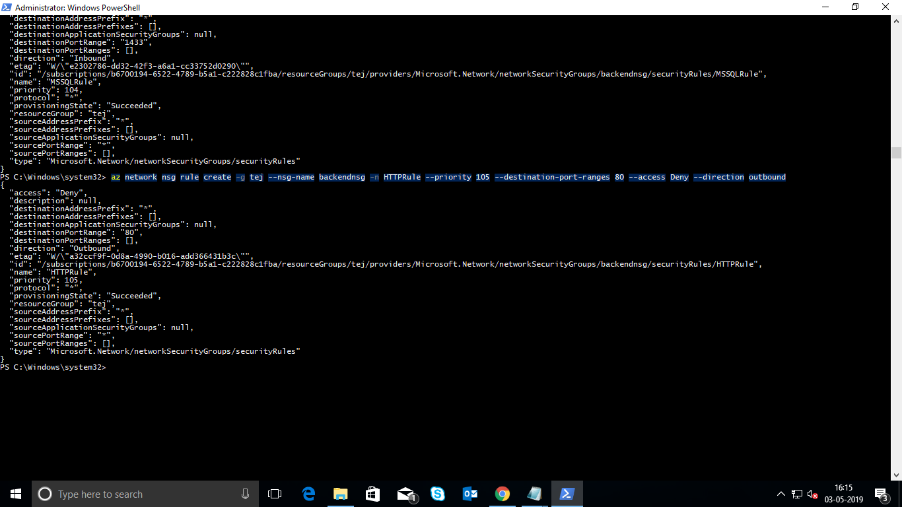

Created a OutBound Properties HTTP rule and in the Backendnsg Group